// TODO add title page image

|  |  |
| --- | --- |
|  | **Debriefing Document** |
|  | UFCF7M-30-2 Game Level Design |
|  | *William Whitehouse 19019239* |

# Contents

Contents 1

Copyright Notice 2

Design Patterns Applied in the Level 3

Guiding Light 3

What is this pattern? 3

Application in the level? 3

Was it effective? 3

Spiral 3

What is this pattern? 3

Application in the level? 3

Was it effective? 3

Landmark 3

What is this pattern? 3

Application in the level? 3

Was it effective? 3

Crossover Point 3

What is this pattern? 3

Application in the level? 3

Was it effective? 3

Alternate Path 3

What is this pattern? 3

Application in the level? 3

Was it effective? 3

Backtrack 4

What is this pattern? 4

Application in the level? 4

Was it effective? 4

Issues 4

Unreal Crash - Lose Cinematic 4

What & Where is the issue? 4

What action has been taken to fix this issue? 4

Can this issue be fixed? 4

External Assets Used 4

# Copyright Notice

This document and its contents are copyright of William Whitehouse - All rights reserved.

Any redistribution or reproduction of part of or all the contents in any form is prohibited other than the following:

* You may print, download, or store a local copy for your personal and non-commercial use only.
* You may copy the contents to individual third parties for their personal use, but only if you acknowledge the document as the source of the material

# Design Patterns Applied in the Level

## Guiding Light

### What is this pattern?

This pattern is when light (e.g. lamps, torches, glowing objects) guide the player to a location, objective or item.

### Application in the level?

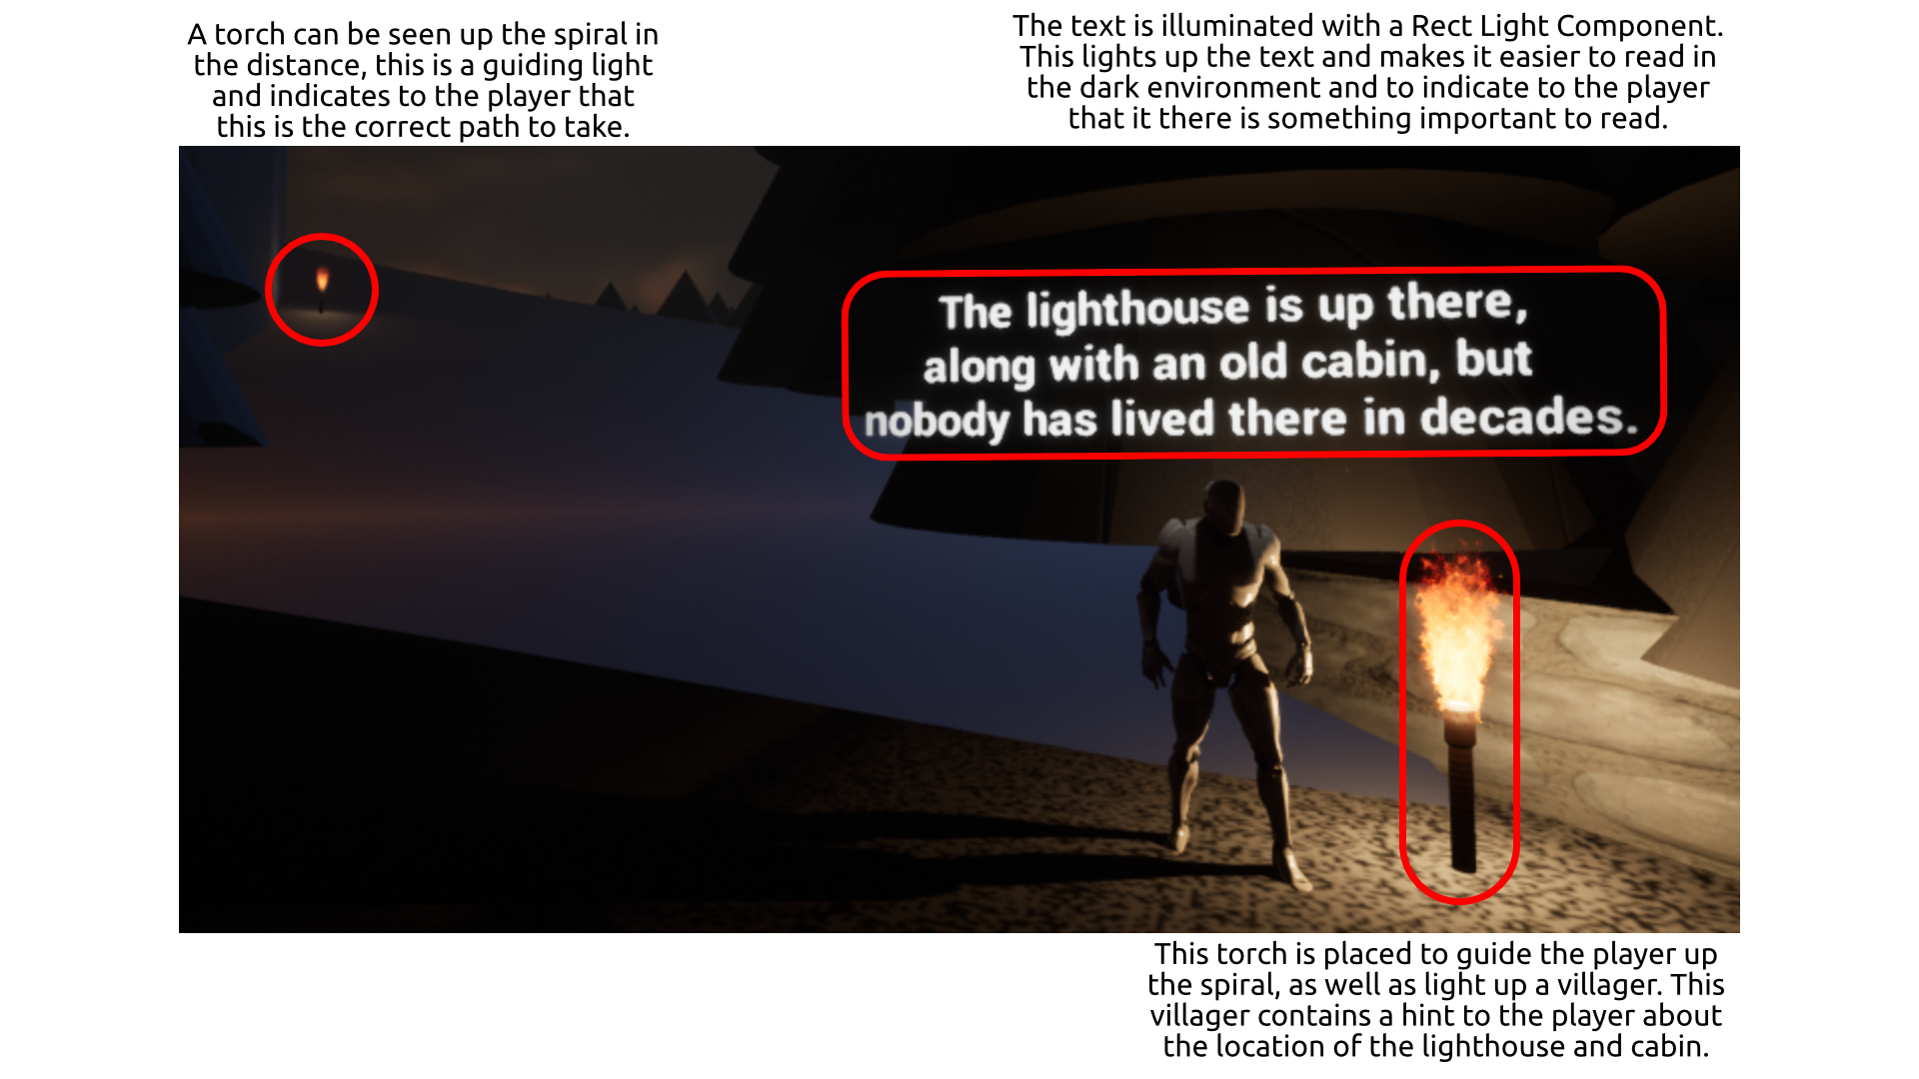

Figure – Guiding Light Pattern Application

### Was it effective?

This implementation was effective, without the torches the level would be too dark to see where to go. Players would not explore certain areas if it didn’t include torches as they are hidden behind buildings. This pattern was especially effective on the final objective (run to your boat) under the time constraint as the fog’s density increases making it difficult to see anything in front of you.

## Landmark

### What is this pattern?

This pattern is a large object in a scene that acts as a visual “point” to the player, it can represent an important area, a goal, or objective. Landmarks are a design pattern that is used in other patterns, such as the Spiral pattern.

### Application in the level?

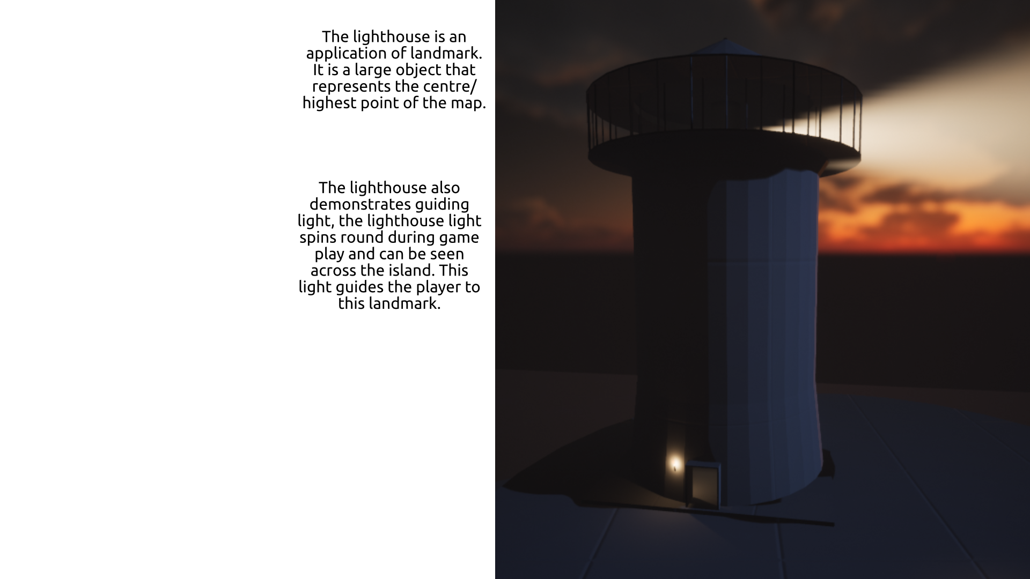

Figure – Landmark pattern application

### Was it effective?

The lighthouse landmark pattern is moderately effective as it is a large object designed to act as a centre point but at far edges of the island it is not visible, and neither is the light. Also, the fact the lighthouse is on top of a high platform (Spiral) its is even harder to see.

## Spiral

### What is this pattern?

This pattern consists of a large piece of land or a mountain with a spiral ramp leading from the bottom to the top. It is designed to allow the player to easily get to a high area and for a landmark in the level as it is very high.

### Application in the level?

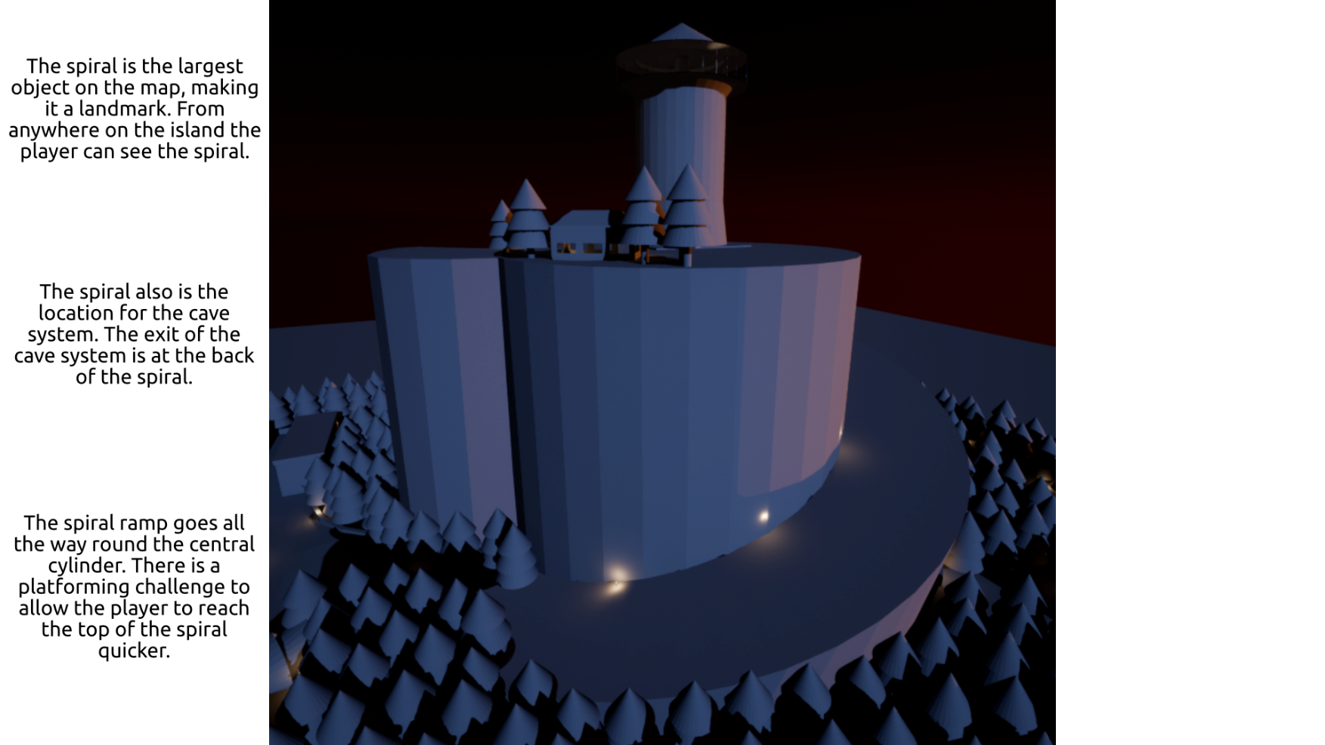

Figure – Spiral Pattern Application

### Was it effective?

The spiral was effective, it served both as a landmark and centre point for the map. The spiral was also effective for including all the caves.

The only issue with this implementation is the aesthetics, the spiral doesn’t look very natural and doesn’t blend in with its surroundings. Its also very large and there are no other height differences or elevations throughout the map, the only elevation is the spiral.

## Alternate Path

### What is this pattern?

This pattern contains multiple paths the player can take to end at the same location, this can include physical paths/areas but also includes different methods of completing an objective or puzzle.

### Application in the level?

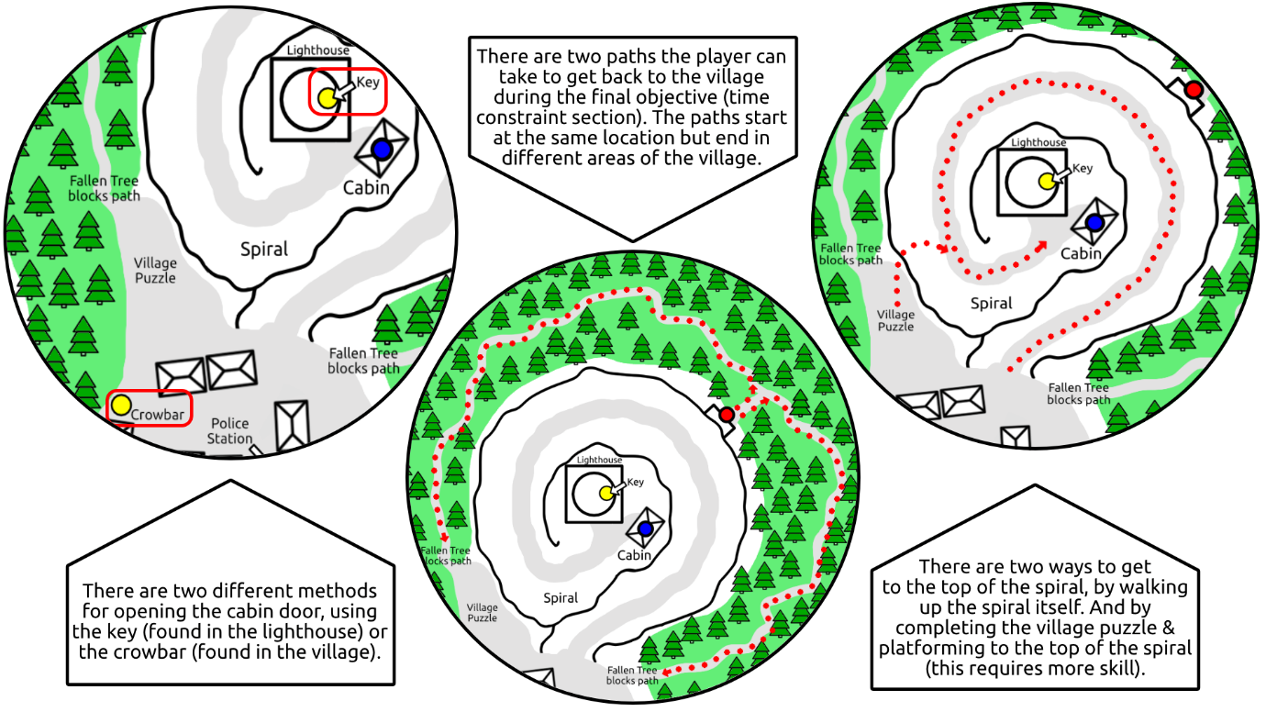

Figure – Alternate Path Application

### Was it effective?

The alternate path pattern was very effective, it made the level more interesting and less linear. It also gave the player a choice, and the level could support many playthroughs each with their own method.

To improve the methods for opening the cabin door, more methods could be added to add more alternate paths. For example, the player could pick up a rock and smash a window get inside.

## Backtrack

### What is this pattern?

This pattern is whenever the player returns or plays backwards an area of a level, for example, using a path to get into a village and then using the same one to exit, or to escape a cave or dungeon.

This also applies to areas in the level, for example, the player could find a puzzle which has the answer to something that was in a previous area of the level. This would force the player to revisit those areas and explore and traverse them backwards.

### Application in the level?

### Was it effective?

# Issues

## Unreal Crash - Lose Cinematic

### What & Where is the issue?

### What action has been taken to fix this issue?

### Can this issue be fixed?

# External Assets Used

This is a table of all the external assets used in the level. To be clear: no logic related assets, e.g. blueprints, materials, particle effects, any asset that was “complete”, etc. were used in the level. Except the Character Controller as this asset was part of the Unreal template the level uses; however, the Character Controller’s blueprints, and logic have been heavily changed (changes & additions).

|  |  |  |  |
| --- | --- | --- | --- |
| Asset | Type | Name & Link | Author |
| Lightning 01 | Sound FX | [Thunder 06](https://www.soundsnap.com/thunder_06_wav_0) | [WW Audio](https://www.soundsnap.com/user-name/willswills) |
| Lightning 02 | Sound FX | [Thunder with rain rolling crisply and slowly in the distance](https://www.soundsnap.com/thunder_with_rain_rolling_crisply_and_slowly_in_the_distance) | [Airborne Sound](https://www.soundsnap.com/user-name/airborne_sound) |
| Lightning 03 | Sound FX | [Thunder with rain bursting and grumble in the distance](https://www.soundsnap.com/thunder_with_rain_bursting_and_grumble_in_the_distance) | [Airborne Sound](https://www.soundsnap.com/user-name/airborne_sound) |
| Lightning 04 | Sound FX | [Slow lightning with background torrential rain](https://www.soundsnap.com/node/58345) | [Airborne Sound](https://www.soundsnap.com/user-name/airborne_sound) |
| Lightning 05 | Sound FX | [Thunder with rain rolling and crackling hesitantly in the distance](https://www.soundsnap.com/thunder_with_rain_rolling_and_crackling_hesitantly_in_the_distance) | [Airborne Sound](https://www.soundsnap.com/user-name/airborne_sound) |
| Rain 01 | Sound FX | [Rain - medium swell - some drops on metal - Neumann RSM 191](https://www.soundsnap.com/rain_medium_swell_some_drops_on_metal_neumann_rsm_191) | [Pole Position Production](https://www.soundsnap.com/user-name/pole_position_production) |
| RocksCollapsing | Sound FX | [Huge stone trap door - releasing rocks and falling-1](https://www.soundsnap.com/huge_stone_trap_door_releasing_rocks_and_falling_1) | [Olivier Girardot](https://www.soundsnap.com/user-name/olivier_girardot) |
| StoneDoorOpening | Sound FX | [Door - stone 4](https://www.soundsnap.com/door_stone_4) | <Soundmorph> |
| Portal_Sound_01 | Sound FX | [Sci Fi Warp Sound 1](https://www.soundsnap.com/sci_fi_warp_sound_1_wav) | [Stormwave Audio](https://www.soundsnap.com/user-name/stormwave_audio) |
| Alien_Screetch | Sound FX | [Alien screetches sci fi horror Nightingale Music Productions](https://www.soundsnap.com/node/110861) | [Nightingale Voice Box](https://www.soundsnap.com/user-name/nightingale_voice_box) |
| Character Controller | Blueprints Meshes Animations Textures Materials | Unreal Third Person Template | Epic Games |
| Blender Meshes *File:*  *Content\Meshes\ BlenderMeshes* | Meshes | Custom “Programmer Art” meshes designed for this level | William Whitehouse |
| Fire_PS | Texture | Unreal Example Assets:  M_Fire_SubUV,  M_Radial_Gradient,  M_Smoke_Sub_UV | Epic Games |
| Rain_basecolor | Texture | [Rain Drops on Screen Effect - (UE4 Tutorial) – Youtube Video](https://www.youtube.com/watch?v=CM-9hqWC0kM) | [UnrealCG](https://www.youtube.com/channel/UCb7A3-CWHgy5EejbfA9wbmw) |
| Cloud_M | Texture | Unreal Example Assets:  T_SmokeSubUV8x8 | Epic Games |
| Key_M | Texture | Unreal Example Assets:  T_Metal_Gold_D,  T_Metal_Gold_N | Epic Games |
| Paper_M | Texture | Unreal Example Assets:  PaperDiffuse,  PaperNormal | Epic Games |
| StoneBrick_M | Texture | Unreal Example Assets:  T_Brick_Clay_Old_D,  T_Brick_Clay_Old_N | Epic Games |
| StrawRoof_M | Texture | Unreal Example Assets:  CASC_Cross,  T_Water_N,  water_n | Epic Games |
| MonsterFX_M | Texture | Unreal Example Assets:  T_Metal_Gold_D,  T_Metal_Gold_N | Epic Games |
| Water_M | Texture | Unreal Example Assets:  T_Water_M,  T_Water_N,  water_n | Epic Games |
| WoodenDoor_M | Parent Material | Unreal Example Assets:  M_Wood_Floor_Walnut_Worn | Epic Games |
| Starter Content | Content | [Unreal Example Starter Content](https://docs.unrealengine.com/en-US/Basics/Packs/index.html) | Epic Games |
| Crouch Animations | Animation | [Animation Starter Pack](https://www.unrealengine.com/marketplace/en-US/product/animation-starter-pack) | Epic Games |
| Death_2 | Animation | [Animation Starter Pack](https://www.unrealengine.com/marketplace/en-US/product/animation-starter-pack) | Epic Games |
| Pushing Animation | Animation | [How to Push an Object with Animations | Movable Objects - Unreal Engine 4 Tutorial – YouTube Video](https://www.youtube.com/watch?v=5cfcaUP8rBo) | [Matt Aspland](https://www.youtube.com/watch?app=desktop&v=5cfcaUP8rBo) |
| Meshes *Folder: Content\Meshes\ Meshes* | Meshes | [Unreal Example Starter Content](https://docs.unrealengine.com/en-US/Basics/Packs/index.html) | Epic Games |